Global Justice Information Sharing Initiative
Infrastructure/Standards Working Group
Meeting Summary
Reston, Virginia
March 1-3, 2004

Meeting Background, Purpose, and Introductions

The Office of Justice Programs (OJP), U.S. Department of Justice (DOJ), convened the Global Justice Information Sharing Initiative (Global) Infrastructure/Standards Working Group (GISWG or Working Group) meeting on
March 1-3, 2004, in Reston, Virginia. In the past few years, this Working Group has been very active, supporting the development of the Justice Standards Clearinghouse for Information Sharing (JSC) and the Global Justice Extensible Markup Language (XML) Data Model (Global JXDM). These tools are aimed at facilitating broadscale information sharing and achieving the Global vision: Leading the way – getting the right information to the right people, in the right place, at the right time.

Moving forward, GISWG will continue to focus on standards but will also turn its attention to the issue of service-oriented architecture (SOA)—its implications, opportunities, and challenges for justice constituencies. While this shift in focus has been evolutionary—tracking with industry development—intensive Working Group reexamination of infrastructure issues can be pinpointed to last spring. A small group of GISWG members, in the course of updating the Global Justice Information Network: An Introductory Report on Infrastructure, determined that SOA can address the challenges inherent to justice-related information sharing: decentralized systems, uncoordinated budgets and funding streams, and the need for interdisciplinary communication—crossing boundaries of disciplines and levels of government. Additionally, since the drafting of the Infrastructure report, two fundamental Global tenets have emerged and must be considered in any infrastructure discussion to align activities with other Global Advisory Committee (GAC or Committee) efforts:

- Global strategies and recommendations should be based on business needs and strongly support “where business is predominantly done”—at the state and local level (i.e., “provide information that supports sound business decisions for the planning, design, and procurement of cost-effective, interoperable information systems”).
- Global strategies and recommendations should be based on “concepts that leverage existing infrastructure, capabilities, and functionality.”

Mr. Tom Henderson, National Center for State Courts (NCSC) and GISWG Chairman, convened the meeting noting, “SOA appears to solve [these outlined issues]
. . . but if we have found nirvana, what does that really mean? What are the implications?” Considering this express intent of exploring SOA, GISWG was reconstituted at the beginning of 2004 with representatives from a different pool of expertise than in the past.

The GISWG meeting agenda items were as follows:

- SOA Workshop
  - A day-and-a-half, intensive introduction to aspects of SOA and associated components (e.g., registries).

- GISWG SOA Document Development
  - A day-and-a-half interactive session, with GISWG members’ input yielding the substance for a draft report that:
    - Defines the requirements for a national infrastructure which will support justice information sharing.
    - Identifies the components of such a national infrastructure.
    - Suggests strategies that local, state, and national officials can use to make the recommended infrastructure a reality.

- Next Steps/Next Meeting

Chairman Henderson invited participants to provide introductions and express their topics of interest with regard to SOA. The following GISWG members, presenters, federal officials, and support staff were in attendance:

John Aerts
Los Angeles County Sheriff’s
Department
Norwalk, California

Kenneth Bouche (Observer)
SEARCH – The National
Consortium for Justice
Information and Statistics
Springfield, Illinois

Philip Broadfoot
Danville Police Department
Danville, Virginia

Ed Chase (Presenter)
Adobe Systems, Inc.
McLean, Virginia

Steven Correll
National Law Enforcement
Telecommunication System
Phoenix, Arizona

Paul Embley
Practitioner Resource Group
Frankfort, Kentucky

Scott Fairholm
National Center for State Courts
Williamsburg, Virginia

Ken Gill (Program Official)
Office of Justice Programs
Washington, DC

Kael Goodman
New York Departments of
Correction and Probation
New York, New York

Bob Greeves (Program Official)
Office of Justice Programs
Washington, DC

Ron Hawley
SEARCH, The National
Consortium for Justice
Information and Statistics
Sacramento, California

Tom Henderson (Chair)
National Center for State Courts
Arlington, Virginia

John Loverude
Joint Task Force on Rap
Sheet Standardization
Springfield, Illinois

Patrick McCreary (Program Official)
Office of Justice Programs
Washington, DC

Duane Nickull (Presenter)
Adobe Systems, Inc.
Vancouver, British Columbia

Karli O’Neal (Staff)
Institute for Intergovernmental
Research
Tallahassee, Florida

James Pritchett
Southwest Alabama Integrated
Justice System
Foley, Alabama
Donna Rinehart (Staff)
Institute for Intergovernmental
Research
Tallahassee, Florida

Gus Sandstrom
10th Judicial District – Colorado
Pueblo, Colorado

Bob Slaski
Advanced Technology Systems, Inc.
McLean, Virginia

Robert Sykora
Minnesota Board of Public Defense
Minneapolis, Minnesota

George Thomas
U.S. General Services Administration
Washington, DC

Chelle Uecker
Superior Court of California
Santa Ana, California

Richard Ward III (Staff)
Institute for Intergovernmental
Research
Tallahassee, Florida

SOA Workshop

Chairman Henderson introduced Duane Nickull and Ed Chase of Adobe Systems, Inc., to guide GISWG members through a day-and-a-half SOA workshop. He explained the context in which the workshop was being presented:

“This Working Group is charged with writing a paper for policy people that doesn’t offend technicians, that will explain what SOA is, what it has to offer the justice community, and the strategies we recommend for making SOA a national infrastructure reality. Coming out of our . . . workshop, you won’t need to be an SOA expert, but you will need to know what the technical requirements are on a general level, so when we talk about where we’re going to invest our [resources], you have a sense of where we are [currently in the justice community, in terms of architecture], and where we are going. . . . To that end, our presenters have been invited to give us a primer. By the end [of the workshop], we’ll all be at the same level, with the same understanding. Then, the last day and a half we’ll focus on the content of the report and draw on your expertise as policy people to help write it.”

Mr. Nickull and Mr. Chase used a series of PowerPoint slides during the workshop. They applauded the Working Group’s interest in the topic, noting the “move to SOA is evolutionary and can be attributed to cultural changes, the competitive marketplace . . . .” As an example, the Canadian government is moving to SOA. “Technology was the easy part—the policy, the motivational aspect, was the hardest part.”

Throughout the workshop, Mr. Nickull emphasized three principles of SOA:
- SOA is service-oriented. It stresses point-and-click ease to end users; complexities of the infrastructure are hidden. “All the magic happens behind the scenes.”
- SOA is event-driven.
- SOA is registry-centric. Per Mr. Nickull, although not completely interdependent, “Registries are the heart of the SOA.”

At the conclusion of the workshop, GISWG members expressed their appreciation, terming the briefing “invaluable.” In consideration of the previous days’ dialogue, Chairman Henderson stated: “Vocabulary is one of our biggest problems. Policymakers still talk in terms of hardware, of building a system. We need to synchronize our vocabulary [with industry].” The Honorable Gus Sandstrom,
10th Judicial District, Colorado, concurred, “We want to go talk to policymakers in terms of ‘linkages,’ not hardware anymore.” Mr. Bob Greeves, Office of Justice Programs (OJP), highlighted another terminology shift, noting that “architecture” is the more appropriate term as opposed to “infrastructure,” which is conceptually broader than suits GISWG’s purposes.

GISWG SOA Document Development

Working Group members devoted the remainder of the meeting time to working towards production of the GISWG SOA document (slated for presentation to the GAC in October). Following the same paradigm as the related previous effort, actual document drafting will be accomplished by a GISWG SOA Document Task Force. However, all Working Group members’ input in the form of content suggestion, specific writing “homework” assignments, and review/editing will be necessary to complete the task. To that end, Chairman Henderson moderated a roundtable discussion, setting the stage by stressing that participants “concentrate on the policy problem we’re trying to solve, which is not how to implement SOA but how to share information nationally. We’re starting with the assumption that SOA is the best solution.” He then solicited responses to the following questions:

- What is required for a national infrastructure?
- What is SOA, and why is it useful?
- What about standards?
- What services are required?
- What about registries?

Exchanges between participants, encapsulated in the following outline, will form the backbone of the GISWG SOA report.

1. What is required for a national infrastructure?

- Need: Separate paradigms/types of sharing.
- Automated processes.
- Ad hoc (nonintermediated systems).
- Need: To incorporate the have-nots.
  - Develop some basic guidelines quickly (i.e., What do I buy? What should it do?).
- Need: Keep in mind the haves.
  - Sharing information downhill and laterally.
- Need: Reconsider business practices in light of technology.
- Need: Simplify/automate.
- Need: Make distinction between processes dealing with the information that is known (active cases) versus intelligence information.
  - Issue re: Boundaries between the two types of information.
- Need: Adequate consideration of data entry/accuracy issues.
- Need: Build bridges/open up/access existing information (versus capturing new information).
- Need: Recognize and accept the justice information sharing landscape as it currently exists, but aspire toward betterment of processes.
- Posed to GISWG members: What do YOU most need (regarding information) to give or receive?
  - When/where grant programs/funding?
  - Person identifier.
  - Sharing of public information.
  - Warrants within a region.
  - All warrants.
  - Photo identification files.
  - Event-driven data.
  - Release date (subscription service)―where they are, how long they will be there?
  - Biometrics identifier.
  - Domain ontology expressed as Unified Modeling Language (UML).
  - Information exchange standards/specifications.
  - Status regarding subject of interest (i.e., Is someone else concurrently “dealing with” the subject?).

  - Status of objects of interest (person, place, vehicle, and property) to people at all levels of government.
  - One-stop, master name inquiry (“Google”-esque).

Coarsely categorizing the above items, attendees feel they most need information on:

⇒ Identity
        - Location
        - Decisions (what/when/where decisions have been made)

2. What is SOA and why is it useful?

Chairman Henderson recounted that on November 10, 2003, in Williamsburg, Virginia, an SOA subcommittee (under the direction of GISWG) convened to have some preliminary discussion on the issue. One of the points tackled was defining SOA, and “while no one definition accomplished all we had hoped, we had but a really good meeting. . . . [However,] the definitions still aren’t going to make SOA accessible to those unfamiliar with the term.” The three definitions proffered by the subcommittee were:

- SOA is a strategy for electronic access to share information about persons and cases in any database you have authority to access at the local, state, and national levels.
- SOA is a policy-driven process to enable interoperability among existing information systems. When combined with the appropriate policies, SOA allows practitioners to get justice data on demand from local, state, and national sources and make it available to decision makers.
- SOA is a business-driven, open-standard software technology systems development process, built on existing infrastructure (e.g., National Law Enforcement Telecommunication System [NLETS], Law Enforcement Tactical System [LETS], and the American Association of Motor Vehicle Administration network [AAMVAnet]) to enable information sharing at the local, state, and national levels that respects current diversity and heterogeneity.

John Aerts, Los Angeles County Sheriff’s Department, added another definition for consideration, taken from the online article IBM’s Sutor: SOA Is So Necessary:

“Essentially, in brief, an SOA is distributed computing where you identify the different units of work or units of activity as services. So a service is some piece of software that you can issue queries to, issue commands to in some way, basically tell it to do something, and it responds back to you. It’s critical that there is a large degree of standardization in how you actually define these services. That is, we can’t have one language for talking about this service and another language for talking about that service. The key is to try to make what is essentially an extremely heterogeneous implementation to look as homogeneous as possible—that is, your service or another service can be described in exactly the same terms and, therefore, processed by exactly the same tools.

Given this notion that I can describe services, I can get those descriptions, I then need to connect to them. And I have certain requirements about that connectivity. So, I have requirements about reliability, that is, I know if I invoke a service I’d like to know that something actually happened. That it got the message and responded back to me.

So it basically boils down to distributed computing with standards that tell us how to invoke different applications as services in a secure and reliable way and then how we can link the different services together using choreography to create business processes. And then, finally so that we can manage these services so that ultimately we can manage and monitor our business performance. . . .

Web services is really the best pure way we know of doing service-oriented architecture right now. Web services is taking off because it’s finally sinking into people that the value that we saw in the Internet around Web pages in the last decade is going to translate to the ability for businesses to really connect with each other and do transactions across the Internet. So once you get to a point where you realize something is inevitable, you then go down a little bit deeper into it. . . .”

Many participants encouraged the use of one of Mr. Nickull’s slides (following) to further explain the SOA concept, highlighting the evolution of information sharing toward SOA.

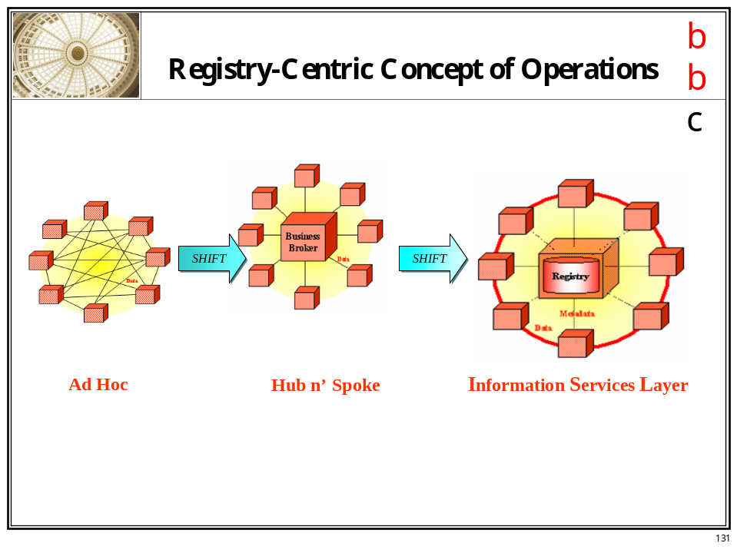

In response to the question “Why is SOA useful?” the Working Group members’ discussion points can be summarized as follows.

SOA:
- Is where industry is and is going.
- Is consistent with the reality of the justice information sharing landscape.
- Allows the realization of benefits we have been after for decades—simpler, faster, and incremental.
- Allows preservation of present investment and leveraging of that investment—no need for big money investment.
- Gives policy choices back to policymakers (re: how they want to share, how they want to access data).
- Has a window now (willingness to share, post-9/11 urgency—attitudinal advantage).
- Responds to frustration of the “as is” landscape.
- Requires resolution: What do we need to do/address to exploit these opportunities?

3. What about standards?

Working Group members determined that three types of standards are necessary—interface standards, data standards, and framework standards. As opposed to starting from scratch, it was noted that SOA standards groups are under way and it will be most advantageous for GISWG to leverage their accomplishments and work. Groups mentioned were electronic business XML (ebXML) (“top-down” standards development), Web Services Interoperability (WS-I) Organization (“bottom-up” standards development), and Organization for the Advancement of Structured Information Standards (OASIS) SOA groups, particularly ebSOA. It was suggested to talk to Paul Wormeli and/or Bob Shumate regarding sending someone from the Industry Working Group (IWG).

Standards-related discussion centered on the following questions/topics:

- Should GISWG develop a WS-I profile?
- What are the minimum attributes that need to be in place to play in the SOA realm (i.e., how do you get into the game)?
- Is this an all-or-nothing proposition? If we already have certain capabilities, why do we want to go to SOA?
- What is the iterative standards process? What strategies should be recommended to “keep the cycle going” (re: review-and-update)?
  - Not a national process, but a local process.
  - Standard software and hardware refresh.
  - “Loosely coupled” equated to easy-to-address, one-at-a-time iterative processes.
  - Data and interface models will serve as reassurance mechanisms, but who is developing these models?
    - Interface model is industry-centric.
    - Data model is not industry-centric.
- Should GISWG address the challenge of getting practitioners involved in the standards development process?
  - Proposition needs to be made more palatable to encourage practitioner involvement; “get the two camps [practitioners and technologists] to talk to each other.”
  - Education and outreach.
    - By whom and to whom?
    - White paper.
    - Bring together standards developers and inform them of “what we need” and the recommended process for doing such.
    - Lessons learned from the XML effort – this “education” is a long-term process.
        - Road shows.
        - Papers.
        - Pilots.
      - What can OJP do?
        - Build participation/travel monies into funding.
        - Sabbatical programs for information technology professionals (months dedicated to the project).
      - When thinking about standards development issues, the group that appears most problematic to the process should be the first constituency brought on board―address the concern early on.

Resolution of the standards discussion: Standards are the salient issue in regards to “services” (discussion following). There is absolutely a need to build on a common framework.

4. Which services are required?

According to Chairman Henderson’s introductory presentation to the GISWG meeting, a “service” can be defined per the following slide:

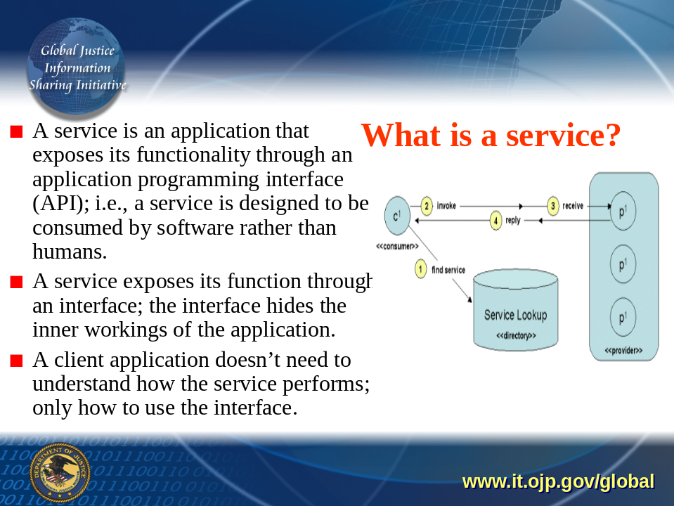

Moving from the slide, the question was posed: From a policy statement, what services (in the broadest sense) are Working Group members looking for? The answer was given: There is a person-centric view, but there is also an event-driven (case) focus (i.e., a triggering event gives the authority to seek information about a person).

Three layers of “services” were identified:

First layer: Individual entity that has what they determine a “service” and want to make this publicly available.
Second layer: Community of interest layer.
Third layer: Gaps identified.

These multilayer, duo-centric responses to discussing the concept of a “service” illustrate the need for the Working Group paper to “describe what WE mean by ‘service.’ Perhaps this is a standards issue.” Roundtable discussion elicited justice service examples, such as:

      - Search commands: “Bring me everything on X.”
      - Populating systems with National Crime Information Center (NCIC) updates.
      - Electronically expunging records.

In addition to the components of “scale” and “speed,” participants vocalized that a service should accomplish/accommodate/address other issues, including:

            - Service provider identification.
            - A business practice—if an agency becomes an authoritative service provider, they should be able to encode business processes and rules into the SOA.
            - Consistency in the base, minimum standard data.
            - Expansion of the sources of services, with the “source” being the entity directly responsible for the information or closely tied to the responsible party.
            - SOA simplifies interfaces, so there are a minimal set of “plugs” needed to access services.
            - Finite set of standards.
            - Registry identification/certification process.
            - Privacy policy consideration/Fair Information Practices principles (led to discussion that some services are public—available to all—but some services should not be exposed to the general populace).
            - Intelligence sharing model/policies, such as 28 Code of Federal Regulations (CFR) Part 23.

5. What about registries?

The discussion of registries began with one Working Group member noting, “The significance [of registries] is that they are essential for the long haul, but the commercial market is not ready and cannot yet support our operational needs.” A suggested response is to decompose registry functions and interagency agreements/memorandums of understanding and begin with those via basic implementations.

Other questions and issues surrounding registries included:

- Will this be a “Global registry,” or a federation of registries?
  - Per Mr. Greeves, GISWG should pursue a federated approach, facilitating linkage with nontraditional partners/information sources (e.g., U.S. Department of Health and Human Services).
- Security/control.
- Lack of maturity of registry technology.
- High-performance transaction processing (policing activities).
- How are linkages staffed? What are the organizational entities?
- Federation issues – dealing with nonplayers, inconsistent models/players per registry, and policy issues.
- “Wait and see” how the Canadian registry performs before GISWG heavily invests.
- How will registries be linked to other major systems (NCIC)? How can the process be accomplished incrementally?
- Funding.
- Building/developing registries versus purchasing commercial registries.
- Performance of a large-scale effort.
- Balancing act: aggressively moving forward to engender interest/buy-in for SOA while balancing caveats, such as the lack of registry maturity/unproven technology.
- Fear of not doing something.
- Getting ahead of the curve of SOA: “If we wait for SOA to be ‘ready,’ something new will be here.”
- Economics/return on investment.
- Attention to inclusion, have-nots.
- Ownership – who pays? Resources for sustainability for valuable long-term program.
- Is the registry capable for discovery?
- Funding streams—how to sell this?
- Amalgamation of all different registries.
- Do not lose sight that the larger goal is SOA, not registries.
- Organization and governance.

Strategies for addressing the issues (above) and additional comments:

- Start process around each enterprise and ask “what do you have, what do you want, and who has it?”
- Pilot projects.
- Leverage private sector (IWG and similar organizations); perhaps establish an SOA subcommittee in the IWG.
- Finding interim methods as SOA matures while simultaneously keeping eye on the larger goal of SOA.
- Make this report immediately useable (capture low-hanging fruit).
- Identify other key stakeholders that are realizing benefit of Global’s work (e.g., DOJ’s Law Enforcement Information Sharing registry and the Office of Management and Budget registry – both of which are likely to include the Global JXDM).
- Have Global recommend to OJP that there be support (funding) for a pilot/modeling exercise(s).
  - Suggestion: NCSC supporting a model registry.
- Strategic question: Should a federation of registries be organized per constituency or should it be across these jurisdictional bounds? And, do we have the authority to make that determination?
- What is our strategy for addressing multiple registries?
  - Implications for standing up a federation of agencies have, implicitly, complex policy issues that preclude “just anybody” putting up a registry.
  - Recognize multiple registries as a given, so focus on registry-based standards to address this reality.
- Move more quickly. If there truly are three layers to consider—data, process, and intent—we should be able to move forward on this.
- Remember the audience for this paper: Technologists? Policymakers? Or both?
- Fait Accompli: The Global XML Structure Task Force, in support of the Global JXDM, will stand up a registry to facilitate inclusion of new elements.
- Leverage SEARCH’s Justice Information Exchange Model tool—a registry is the logical next step.
  - Experiment within this scope.
  - Determine benefits/lessons.
  - Principle of scalability: Begin with incremental efforts (e.g., Automated Regional Justice Information System).

The following points summarize the discussion on registries:

- Registry technology is still immature and evolving.
- We should not wait until SOA is mature to start—need to test, pilot, models (emphasis on plural). (Colorado was suggested as a promising practice.)
- Begin addressing policy issues surrounding SOA—disciplines and interdisciplinary.
- Standards, standards, standards!
- Do not get hung up on registries—keep them in mind, but SOA is not solely dependent on registries.

Next Steps/Next Meetings

The GISWG SOA Document Task Force met after adjournment of the full GISWG to outline a development strategy. This will include incorporating Working Group members’ “homework assignments” that provide illustrations of “what SOA has to offer”: descriptions of situations/tasks—currently laborious processes—that lend themselves to SOA solutions. These scenarios will “anchor the [SOA] solution for policymakers.” Assignments were asked to be sent to Task Force chair John Loverude no later than Thursday, April 15, at loveruj@isp.state.il.us and copied to Ms. Donna Rinehart, Institute for Intergovernmental Research at drinehart@iir.com. Via conference calls and e-mails, the Task Force anticipated a first draft for Working Group review by the next GISWG meeting slated for late May (25-27)/early June (7-9), tentatively in the vicinity of Tampa, Florida, or San Diego, California. Chairman Henderson thanked the presenters and Working Group members for their participation and expertise: “As a result of the past three days, we have a solid set of information to incorporate into the paper.” Having no further business, and hearing no further questions, the GISWG meeting was adjourned.

Located at http://www.search.org/publications/pdffiles/Global_Ifrastructure_Report.pdf.
Global Strategic Plan guiding principle.
Ibid.
These slides were electronically transmitted to attendees and are available to other interested parties by contacting (850) 385-0600, extension 285. Due to the number of the slides, they are not included as an attachment.
Chairman Henderson’s roundtable discussion outline originally included treatment of interagency agreements. However, this issue was not covered extensively by the group and will be remanded to the SOA Document Task Force for further study.
Located at http://www.eweek.com/article2/0,4149,1538914,00.asp.
More information located at http://www.ebxml.org/.
More information located at http://www.ws-i.org/.
Transmitted to GISWG members electronically by Working Group staff member. Attendees who did not receive their assignment or would like the list of tasks resent, please call (850) 385-0600, extension 285.
As one participant noted: “By describing a small set of the problems we are trying to solve, and how to solve those problems (via SOA), the light bulbs go on.”

